**MythicaLand**

Introduction

Genre : Adventure, Educational

Age Rating : 5 to 7

MythicaLand is a Game App that focus on education for children. It aims to teach simple knowledge on Animals, Colours, Household Items etc. while not making studying boring, implementing a story and gameplay will make learning more interesting that way.

Objective

Our objective is to help the children be able to learn while having fun at the same time during times where they are not able to attend school. Ultimately, we also aim to have this app help children who are having trouble understanding in class or those that wanted to know more could also choose to use this App to help them.

Why this App

The reason why we chose to create a game app focusing on education is firstly because other types of application such as travelling app or apps that aim to make the user’s life much more efficient and simpler if they were to use it. Secondly, because of the current situation of Covid-19, everybody is to stay at home and students is not able to attend school which includes the children at the age of 5 to 7 will not be able to attend the school and learn things which they would be taught and will have to depend on their parents which in some cases they would be busy working.

Idealization Process

Stage 1 – First Idea

MythicaLand will contain 4 story each with a different gameplay mechanics to stand out from each other, there will not be a login account as the story will be short and simple just to teach them very simple information.

Mainly because we wanted to teach different things in different story so the first idea is to have multiple different stories to make the player can enjoy different story while learning different thing, in short different experiences.

Stage 2 – Realization

Change to 1 story with 4 chapters and each chapter with a different gameplay mechanics at the end of the story.

We realize that our team does not have enough time to create so many stories, so we cut off into 1 story but cut into parts called chapters, which greatly reduce our workload and increase our efficiency.

Stage 3 – Final idea

1 story with 3 chapters, each with a different gameplay mechanics at the end of the story and an additional option page to change BGM and SFX volumes.

After trying to implement audios in, we realize we need to be able to give players the option to adjust their volumes to suit their needs so 1 chapter to be cut off for the creation of the option page.

UI Design

1. Main page, consist of the title of the game and 3 buttons

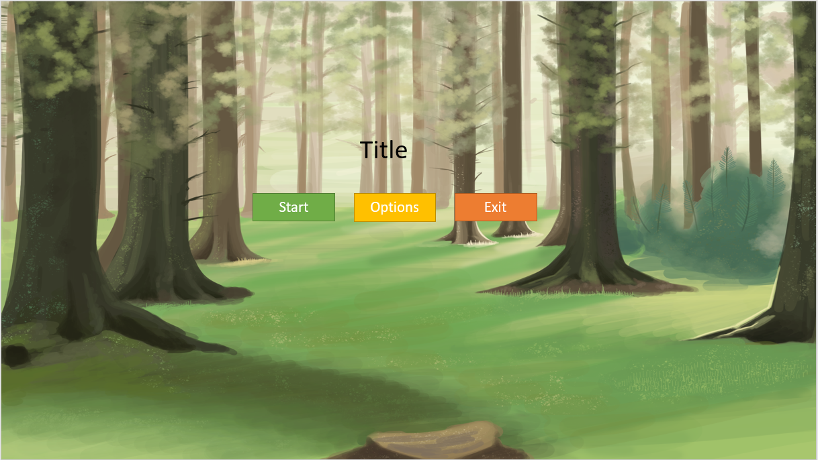

1a. Alert-Dialogue, when player click on the Exit button in the main page, this will appear prompting user whether to quit or not.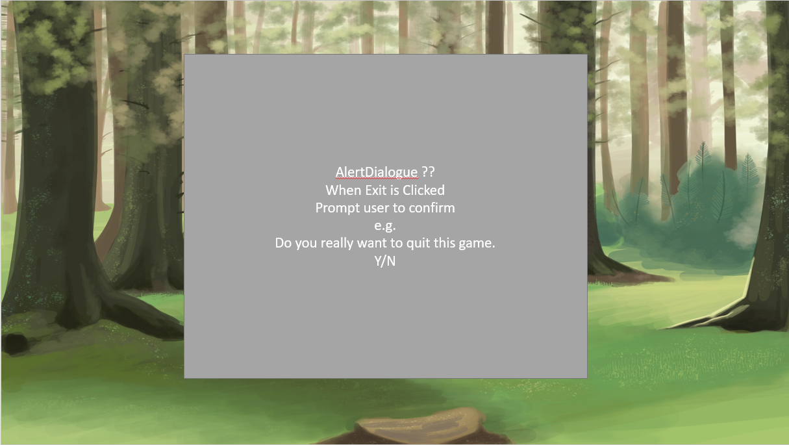

2. Option Page, it allows the player to set the volume of the game according to their liking

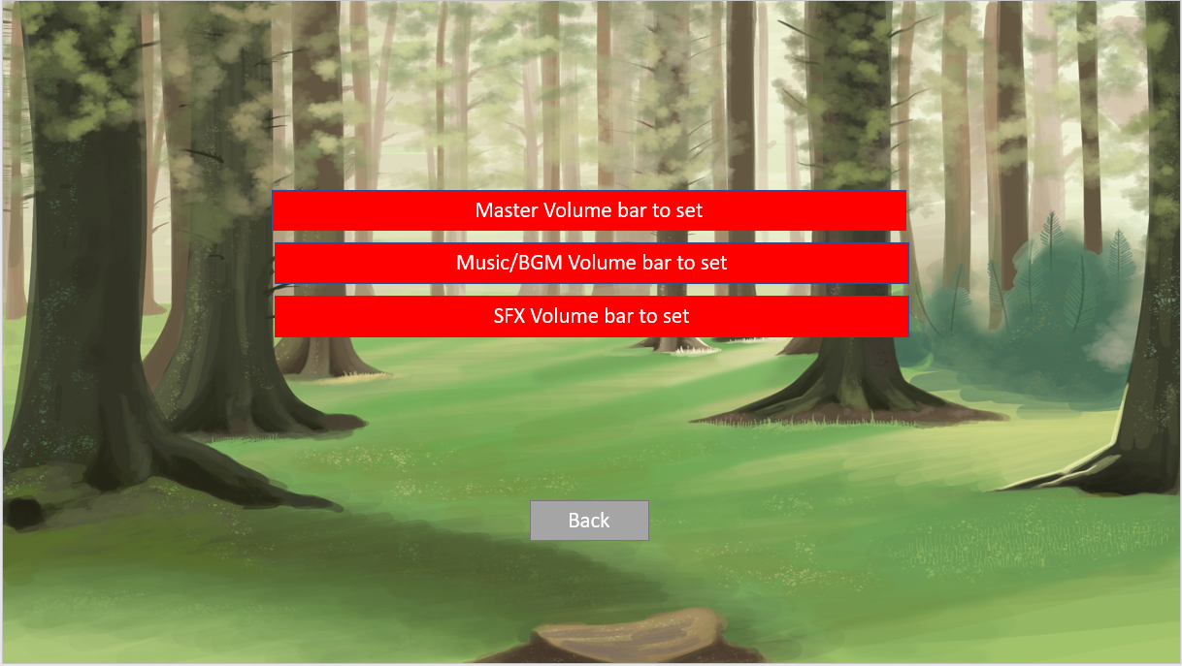

3. Chapter Page, consist the 3 chapter’s button that will lead to their respective storyline.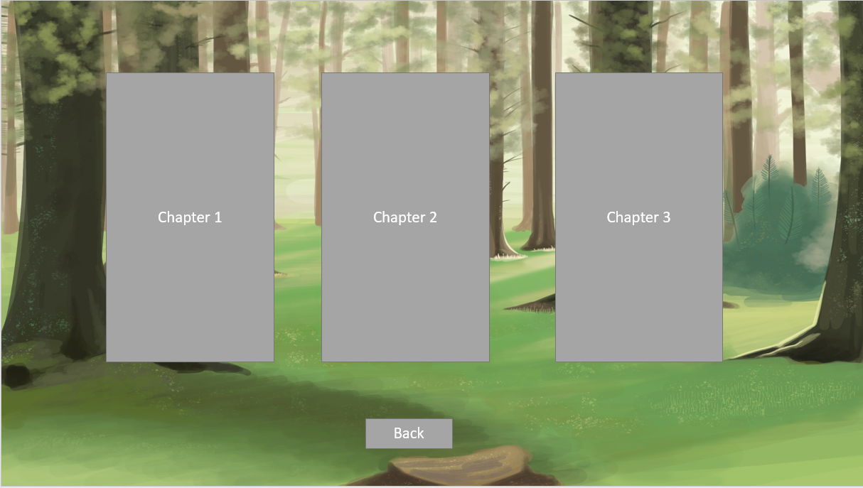

4. Story Page, consisting of the character image, the dialogue box and the buttons to continue the dialogue or go back to main menu.

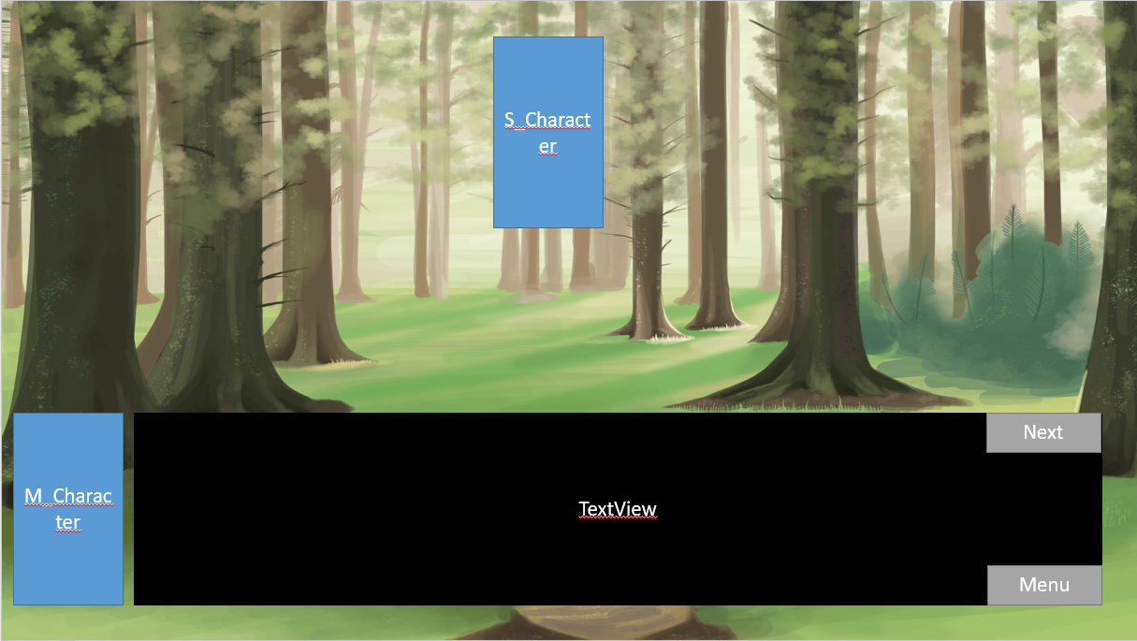

4a. Alert-Dialogue in story page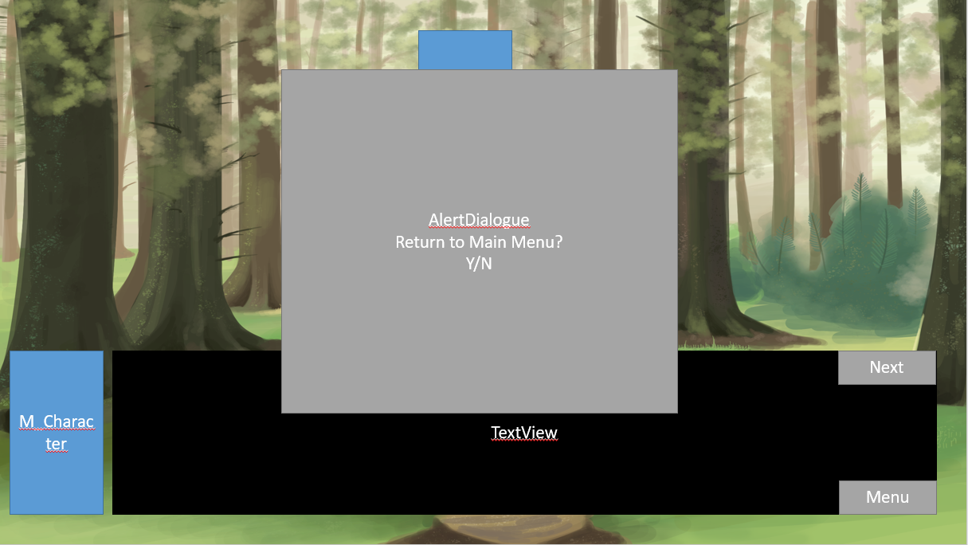

5a. Chapter 1 gameplay, Quiz type, tick on the checkbox and press confirm 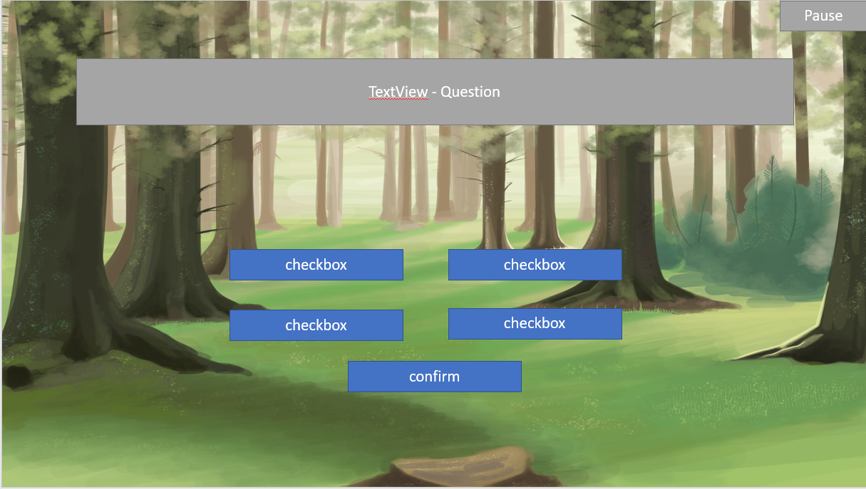

5b. Chapter 2 gameplay, point and click type. 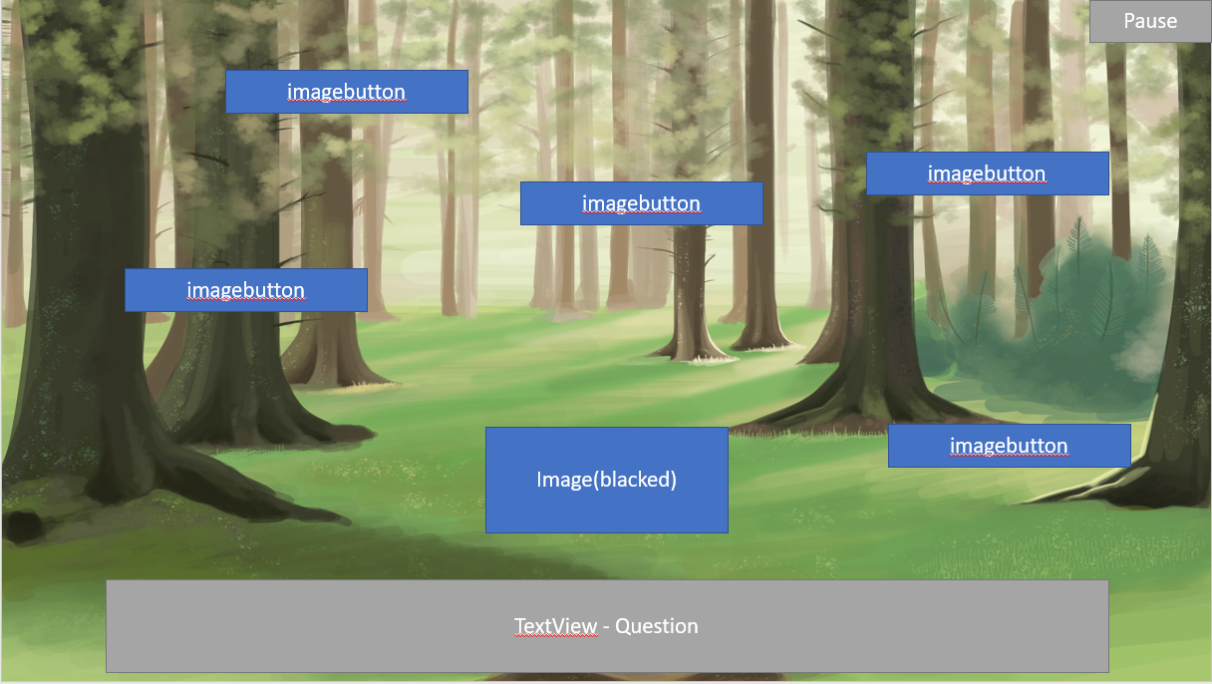

5c. Chapter 3 gameplay, Quiz type, answering the question by typing the correct answer in the answer slot.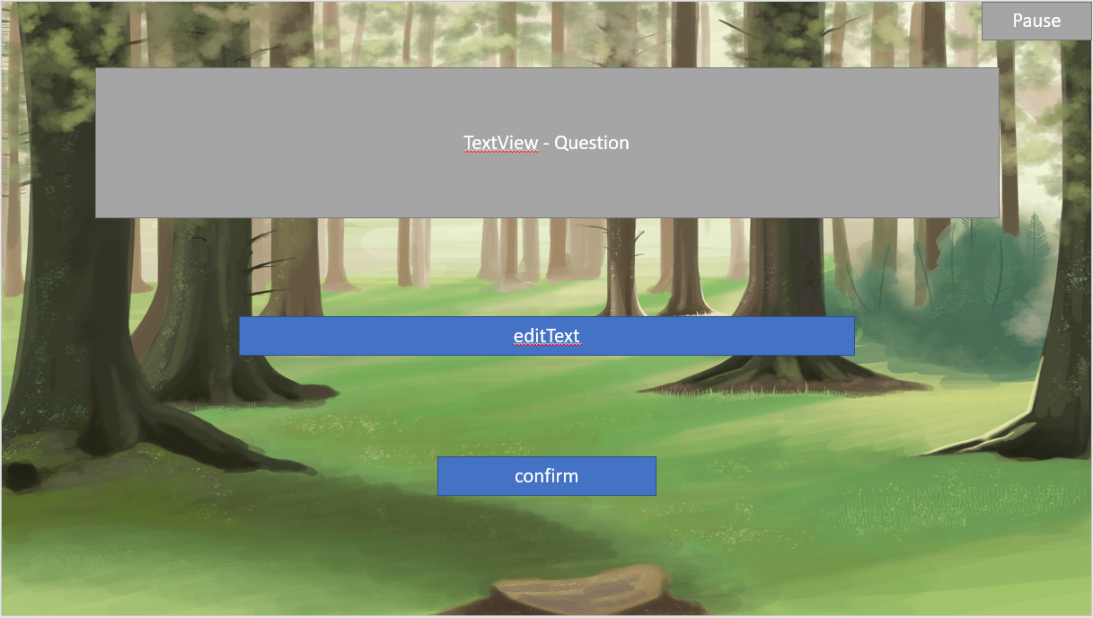

5d. Alert-Dialogue, a customized type with resume or return button instead of yes or no.

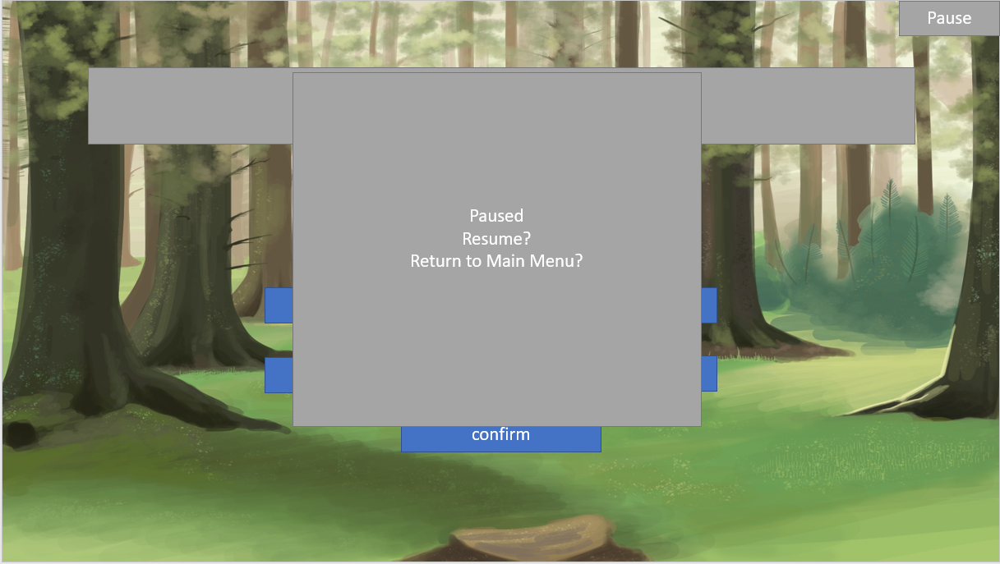

Current Product

1. Main Menu

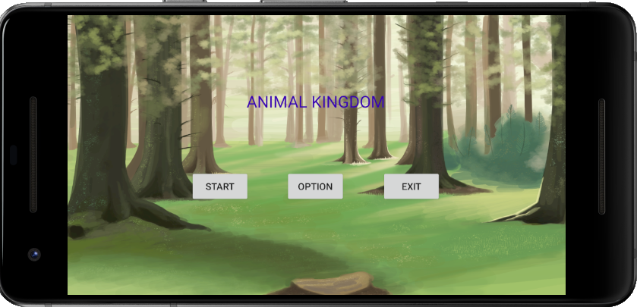

1a. When Exit button is pressed in the Main Menu.

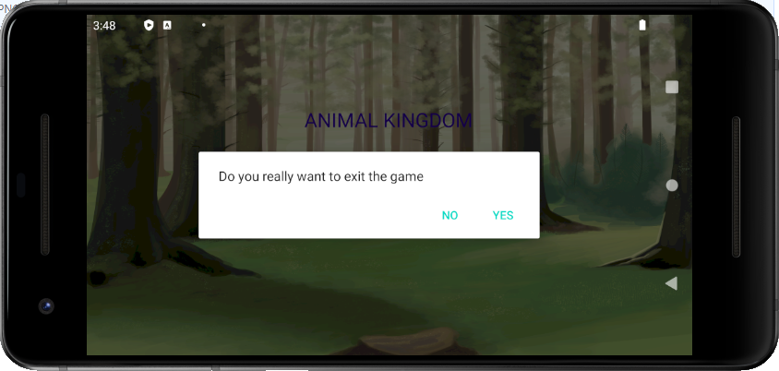

2. Option Page

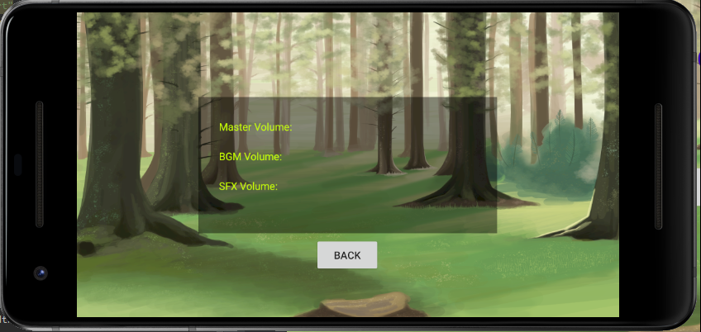

3. Chapter Page, currently only have 1 chapter

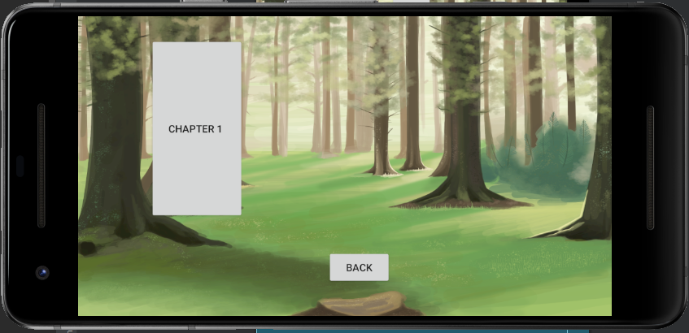

4. Story Page, when Chapter 1/2/3 is pressed, player will be directed to this page.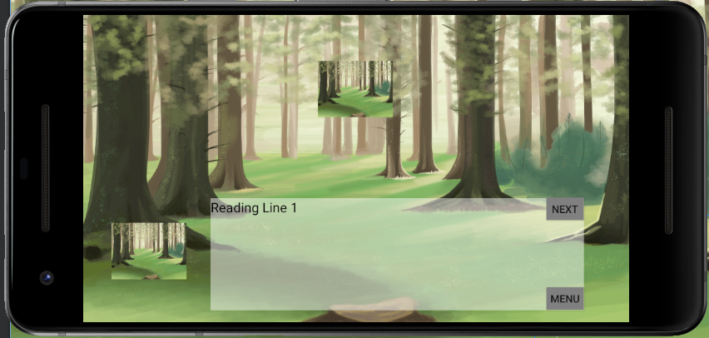

5. When Menu button is pressed in the Story Page.

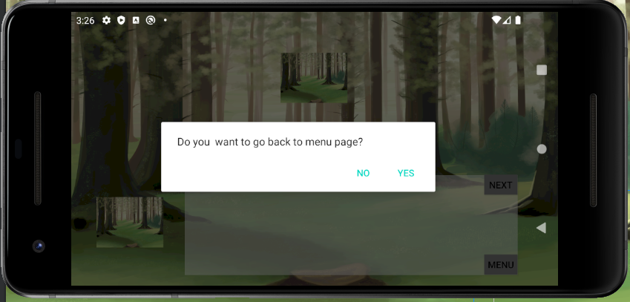

Features

Current Features included :

* Images
* Audios
* SQLiteDatabase
* Hiding System UI

Features to be Included :

* Gameplay Mechanics
  + Checkbox and Submit
  + Point and Click
  + Type Text and Submit
* Volume Adjustments

Changes to be made

**Fragment**

Currently the Layout is created individually where from one page going to the other is through the “Intent” method, but by using the fragment method, at no point the page is moving from one to the other but simply just changing the fragment that is located in the main page, technically it is still changing from one layout to the other but there are reasons for doing this.

1) When transferring from one layout to the other using the intent method, the System UI actually pops out for a second before hiding itself again which creates the point of switching not smooth

2) When fragments are used instead of intents through pages, fragments made it so that everything is on one page and only the fragments are switching back and forth, this makes it possible for a music to be playing through without pauses or suddenly replaying it again.

**Recycler View**

There are ideas of implementing a Recycler View Horizontal Style in the Chapter page, this would allow us to create new chapters and include into the Recycler View instead of having to create more buttons and trying to resize them to fit the page itself.

**Buttons**

Increase the button size and implementing motion to the button to visually tell the player that this is something that is important. The motion of the button will either be floating with shadow or given a border that zoom in and out.

Technical Risk

This is the first time the team will be using Fragment to do our layouts and switching between fragments, so if possible using fragments instead of Intent method is one of our goal and there is chances that it may not work and have to re-plan to use back the Intent Method.

Depending on time restriction, recycler view might not be implemented as most of the game story and art have not been finished and so only after the base is done then the team will try to implement the recycler view in.

Button Motion implementation will have to depend whether there is time to created it same as recycler view as time constraint is an important thing that is preventing us from doing it and the biggest constraint is that button motion or creation of a motion to an object is not something my team has experience with so this might not be implemented at all.

Team Members Contribution

Jing Xiang

* Created Main Menu
* Created Audios
* Hide System UI
* Created SQLiteDatabase

Nicole

* Artist
* Created Chapter Page
* Created SQLiteDatabase

Shangetha

* Created Story Page
* Created Storyline

Sian Wu

* Created Option Page
* Created Page Designs